**WEEK-4**

REST - Get country based on country code 

Country.java

package com.cognizant.spring_learn;

import org.slf4j.Logger;

import org.slf4j.LoggerFactory;

public class Country {

private static final Logger LOGGER = LoggerFactory.getLogger(Country.class);

private String code;

private String name;

public Country() {

LOGGER.debug("Inside Country Constructor.");

}

public String getCode() {

LOGGER.debug("Inside getCode");

return code;

}

public void setCode(String code) {

LOGGER.debug("Inside setCode");

this.code = code;

}

public String getName() {

LOGGER.debug("Inside getName");

return name;

}

public void setName(String name) {

LOGGER.debug("Inside setName");

this.name = name;

}

@Override

public String toString() {

return "Country [code=" + code + ", name=" + name + "]";

}

}

SpringLearnApplication.java

package com.cognizant.spring_learn;

import org.springframework.boot.SpringApplication;

import org.springframework.boot.autoconfigure.SpringBootApplication;

@SpringBootApplication(

exclude = {

org.springframework.boot.autoconfigure.jdbc.DataSourceAutoConfiguration.class,

org.springframework.boot.autoconfigure.orm.jpa.HibernateJpaAutoConfiguration.class

}

)

public class SpringLearnApplication {

public static void main(String[] args) {

SpringApplication.run(SpringLearnApplication.class, args);

System.out.println("App is running...");

}

}

Country.xml

<?**xml** version=*"1.0"* encoding=*"UTF-8"*?>

<**beans** xmlns=*"http://www.springframework.org/schema/beans"*

xmlns:xsi=*"http://www.w3.org/2001/XMLSchema-instance"*

xsi:schemaLocation=*"*

*http://www.springframework.org/schema/beans*

*https://www.springframework.org/schema/beans/spring-beans.xsd"*>

<**bean** id=*"in"* class=*"com.cognizant.spring_learn.Country"*>

<**property** name=*"code"* value=*"IN"* />

<**property** name=*"name"* value=*"India"* />

</**bean**>

<**bean** id=*"us"* class=*"com.cognizant.spring_learn.Country"*>

<**property** name=*"code"* value=*"US"* />

<**property** name=*"name"* value=*"United States"* />

</**bean**>

<**bean** id=*"countryList"* class=*"java.util.ArrayList"*>

<**constructor-arg**>

<**list**>

<**ref** bean=*"in"* />

<**ref** bean=*"us"* />

</**list**>

</**constructor-arg**>

</**bean**>

</**beans**>

Countryservice.java

package com.cognizant.spring_learn.service;

import com.cognizant.spring_learn.Country;

import org.springframework.context.ApplicationContext;

import org.springframework.context.support.ClassPathXmlApplicationContext;

import org.springframework.stereotype.Service;

import java.util.List;

@Service

public class CountryService {

public Country getCountry(String code) {

ApplicationContext context = new ClassPathXmlApplicationContext("country.xml");

List<Country> countries = context.getBean("countryList", List.class);

return countries.stream()

.filter(c -> c.getCode().equalsIgnoreCase(code))

.findFirst()

.orElse(null);

}

}

Countrycontroller.java

package com.cognizant.spring_learn.controller;

import com.cognizant.spring_learn.Country;

import com.cognizant.spring_learn.service.CountryService;

import org.springframework.beans.factory.annotation.Autowired;

import org.springframework.context.ApplicationContext;

import org.springframework.context.support.ClassPathXmlApplicationContext;

import org.springframework.web.bind.annotation.*;

import java.util.List;

@RestController

public class CountryController {

@RequestMapping("/country")

public Country getCountryIndia() {

ApplicationContext context = new ClassPathXmlApplicationContext("country.xml");

Country country = (Country) context.getBean("in");

return country;

}

@GetMapping("/country/{code}")

public Country getCountry(@PathVariable String code) {

ApplicationContext context = new ClassPathXmlApplicationContext("country.xml");

List<Country> countries = (List<Country>) context.getBean("countryList");

return countries.stream()

.filter(c -> c.getCode().equalsIgnoreCase(code))

.findFirst()

.orElse(null);

}

}

OUTPUT

BROWSER

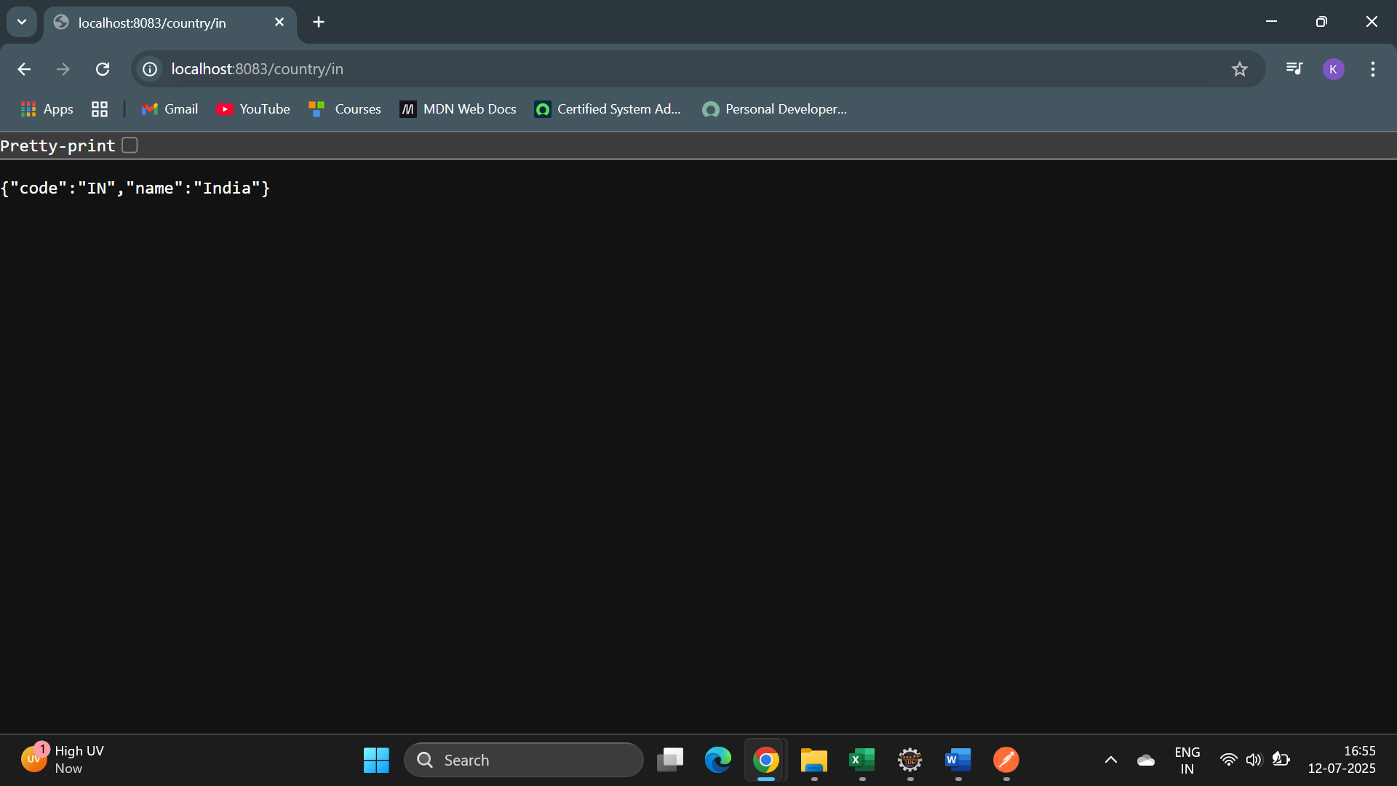

POSTMAN

